**Report Template**

**Organisation:**

**Technician:**  Chris Dworczyk **Date: 15/03/2017**

**Introduction**

Help Desk Trouble Ticket #190677 was submitted at 9:48am on 15 March 2017, a request by a IT lecturer Mr C Boyle for a LAN of 4 PCs and a Switch to be connected together and Windows 7 Pro and Microsoft office installed. The machines were to be set up in a workgroup to allow them to share files. No access to the internet is required. There was an admin user and a student user to be setup. The technician was to set up the password for administrator but not to inform the lecturer of said password and the student user password to be “password”(not including quotes). Having done so and checked connectivity informed the lecturer to allow him to use this network for his class.

But, two days later, the lecturer put in a complaint that one of the machines was not connecting, can ICT investigate.

I decided that I would attempt to resolve the problem in the following systematic manner:

**Investigation**

My first step of action was to ask the lecturer was questioned to try and figure out any possible changes that may have been made to the computer. From the lecturer we were able to find out the student users have heard about the Microsoft test password which was used to set up the admin account. This means that one of the students might have been granted access to a computer where they could change networking settings.

Before proceeding I made sure to check the physical connection of the computer were properly attached. Things like the switch or the cables connecting each computer to the switch. However I wasn’t able to find any problems with ti so I moved onto the software side of troubleshooting.

I pointed out that using default passwords or test password for important workstation is dangerous and can lead to unwanted personnel messing with settings.

To find out which computer is having trouble connecting we can use the IP config command which can be seen being used in appendix A. This allows us to see each of the computers IP addresses. In there we can see that all the computer follow a pattern off 192.168.1.xx - X being the computer number ranging from 1-4 – one of the computers however has a 10 instead of a 1 in its place. This is a simple mistake to fix and is probably the main cause of the problem. To test the connection we ping the suspect computer and we can see in appendix B that we get “Failed Connection” further proving that the suspect computer is the problem.

Most likely what happened is one of the students went onto the computer and managed to guess the Microsoft password and went into network settings and accidentally changed the IP address in one of the computers.

**Plan and implement a solution**

After some thought I have decided that the best course of action is as follows:

1. On the suspected computer go into the network and sharing centre
2. Go into the IPv4 settings and correct the IP address error

No other resources are required to proceed with these steps.

As shown in appendix C the IP address had to be changed from 192.168.10.4 to 192.168.1.4 to match the other computers.

Once this small change was applied the computer was restarted and returned to normal working order.

**Document the steps**

When entering the room I was met with 4 computers each with a password. The password were the Microsoft test password, this being one of the problems. To guess I tried simply “”p@ssw0rd” but it never worked. I then tried a more advance one like “p@$$w0rd” but this still didn’t seem to work. Then finally all that had to be added was a capital letter making it “P@$$w0rd”. From the surface it seems like a string password but these types of passwords are one of the weakest since so many people know about them.

First thing that was done is opening up the command prompt and entering the ipconfig which shows the current computer network IPs and settings. This allows me to see each IP address and find the suspected station. From this I learned that each station follows an IP pattern of 192.168.1.x which made it easy to find the problem.

# Appendix A – ipconfig command

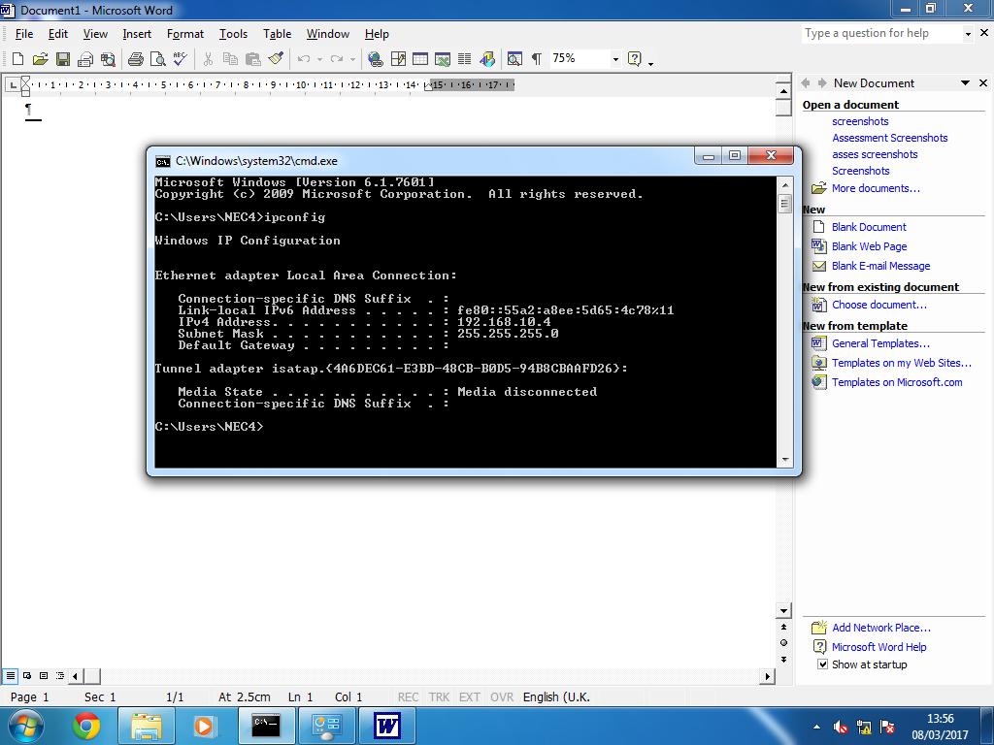

I pinged the suspected computer and received connection failed understandably. From here I moved onto the networking and sharing centre on the suspected computer.

# Appendix B – Pinging the offline computer

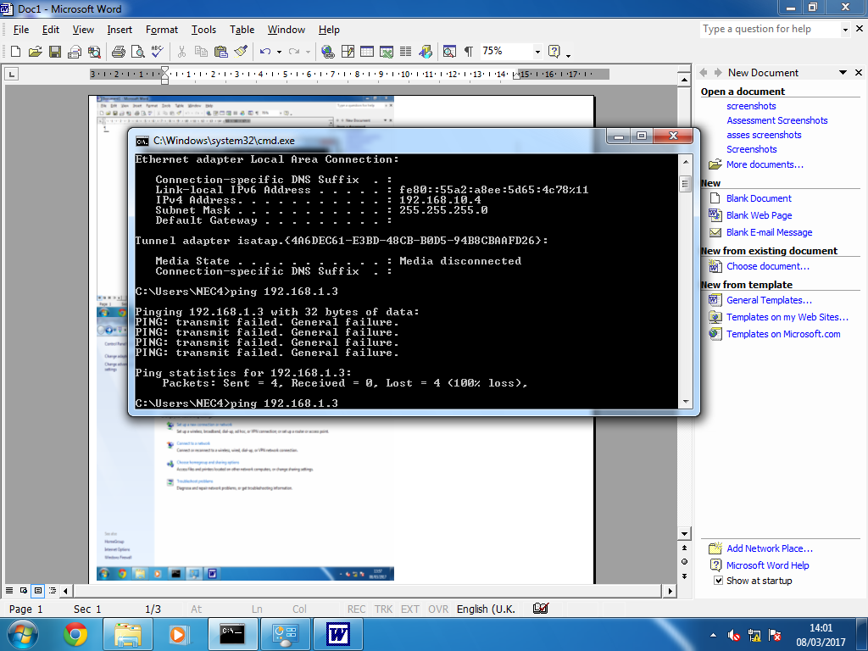

# I went into the networking and sharing centre, clicked the local network and went into the properties. There I found the IPv4 and changed it to the correct one.

# Appendix C – Wrong IP address

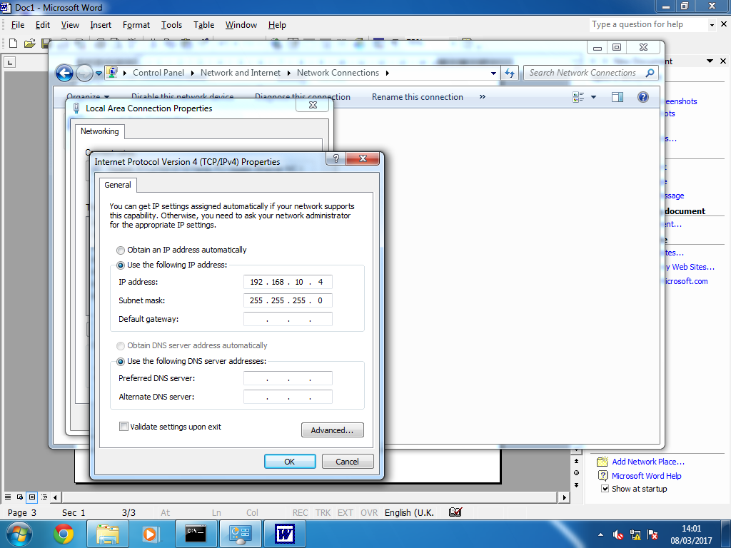

**Review and evaluate**

In general the problem solving process was effective and I’m happy with the solution. From talking to the lecturer we were able to find out key information such as that a student might have had access to the computer networks.

One recommendation I have to make is simply to improve your passwords to be much more strong and secure to prevent any accidents like these happening in the future.

A good password that would make use of symbols, numbers, spaces and capital letters similar to the password “P@$$w0rd”.

For example a simple passwoird such as “apples123” could be “@pple5 123”.